Group Member Information:

Name: Alex Tellez

Email Address: [agt180004@utdallas.edu](mailto:agt180004@utdallas.edu)

Name: Muhammad Khan

Email Address: [mak170003@utdallas.edu](mailto:mak170003@utdallas.edu)

Name: Anthony Lee

Email Address: [lxa151030@utdallas.edu](mailto:lxa151030@utdallas.edu)

Protocol Design: User Datagram Protocol (UDP)

Programming Environment Used: Muhammad Khan - Eclipse, Anthony Lee - Eclipse, Alex Tellez - IntelliJ IDEA

Instructions to Compile and Execute Programs: Please run the server followed by the client.

Parameters Needed During Execution: Client has to enter their name followed by their equation.

Functionality:This project is completed under an environment of manipulating with two single digit numbers (00 -> 09). Server accepts equations from the user which consist of either addition, subtraction, division, multiplication with numbers ranging from 00-09. Then it returns the result to the appropriate client.

Challenges Faced:

**Muhammad Khan** - The challenge I faced was to find a way around using the reset functionality. So instead of using the reset functionality, I used limiters.

**Anthony Lee**- The challenge I faced was to remove trailing zeros from the answer in the client portion. In order to solve this, I used charAt() and number range statements.

**Alex Tellez**- The challenge I faced was figuring out how to keep track of each client since the UDP protocol is a connectionless protocol. I attached an alphabet letter at the beginning of the data being sent from the client to the server to identify which client is sending what equation.

Learning Outcomes of This Project:

**Muhammad Khan** - I learned refined my skills of using a regular expression. Furthermore, I have learned how to set up a single client and server connection.

**Anthony Lee**- I learned that in the UDP environment, there wasn't any setup for the server to serve multiple clients. Also, it helped me to understand how data is packed into packet and sent from server to client and vice versa.

**Alex Tellez**- I learned how the UDP protocol operates in an application using Java. I was able to get a clearer image of how the data is processed and the packet exchange occurrence between the client and server side.

Output of the Application:

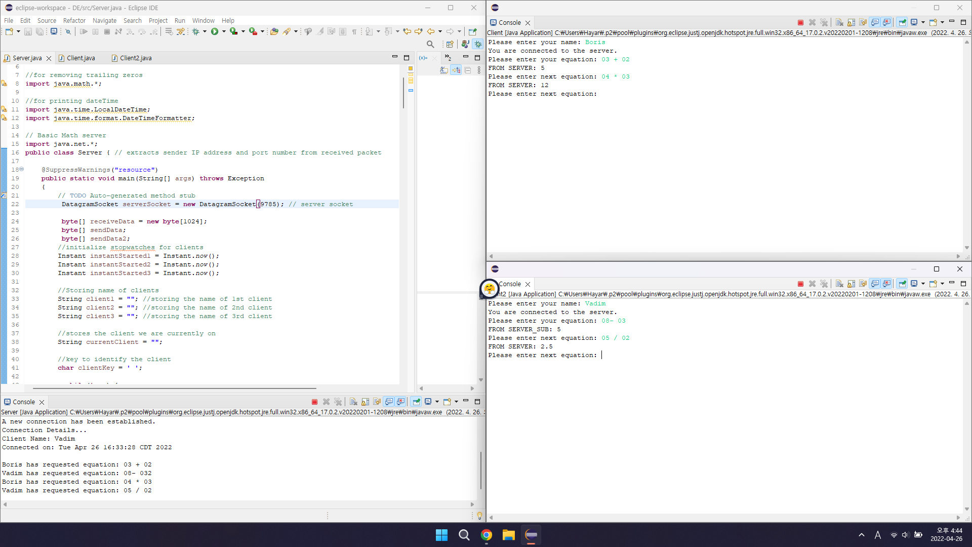

Work Division:

**Muhammad Khan** - I was responsible for setting the regular expression which would be used for input validation. Furthermore, I was responsible for setting up the server side for the math functions (addition, multiplication, division, and subtraction). Lastly, I set up a single client for the program to function with the server.

**Anthony Lee**- I was responsible for checking the functionality of the program in terms of one server and multiple users. Also, for the optimization of the program, I made the send function’s size to be dynamic rather than fixed for minimized traffic.

**Alex Tellez**- I was responsible for keeping track of the clients information, the time they connected/disconnected, the duration of the connection, and who was making what equation request. I was responsible for letting the server know when the client had terminated the connection.